

FACULTY OF COMPUTER SCIENCE AND IT

Bachelor’s in Artificial Intelligence

Project
Real vs AI Image Detection

Worked by: Rabije Zekthi & Xhoana Pole Accepted by: Anxhelo Shehu

Tirana, 2026
- Introduction
Not long ago, the idea of a computer generating a realistic human face from scratch seemed like science fiction. If you wanted a convincing fake image, you needed a skilled graphic designer, hours of work, and expensive software. The result was often imperfect, distorted eyes, unnatural lighting, or blurred backgrounds that gave the illusion away.
Over the past decade, a new wave of artificial intelligence tools, known as generative AI , has fundamentally changed what it means to create an image. Platforms such as Stable Diffusion, Midjourney, and DALL-E can produce a photorealistic portrait of a person who has never existed in under five seconds. These images are not edited photographs. They are entirely synthetic invented by algorithms, yet they are nearly indistinguishable from reality to the naked eye.
This shift did not happen overnight. It began in 2014, when a researcher named Ian Goodfellow introduced the concept of Generative Adversarial Networks (GANs), an idea where two competing AI systems play an endless game of "real or fake" until one of them becomes expert level at creating deceptions. By 2022, Stable Diffusion had been released to the public for free, placing the power to generate photorealistic imagery in the hands of anyone with a laptop.
1.2 The Problem, Trust in the Age of Synthetic Reality
The challenge we now face is not simply one of technology. It is a challenge of trust.
Every day, billions of images are shared across social media platforms, news outlets, courtrooms, hospitals, and financial institutions. Society has always operated on the assumption that a photograph represents something real that happened, somewhere, at some point in time. That assumption is no longer safe.
Today, a single individual with no artistic skill can produce:
- A photorealistic image of a politician committing a crime that never occurred.
- A falsified identity document used to open a bank account.
- A synthetic medical scan used to commit insurance fraud.
- A fabricated "witness photo" submitted as evidence in a legal case.
In 2023, AI-generated images of the Pentagon allegedly being bombed briefly caused the U.S. stock market to dip , because the images looked completely real. In elections around the world, synthetic media has been weaponized to spread disinformation. And as the tools become more accessible, the problem will only accelerate.
The core issue is this:we do not currently have a reliable, scalable, and accessible system that can look at an image and answer the most important question: Did a camera take this, or did a machine make it?
1.3 Why This Problem Matters
It affects every person, every institution, and every business that depends on visual information being trustworthy.
For individuals, Synthetic images can be used to fabricate someone's appearance in a compromising scenario, destroying reputations, damaging relationships, and causing real psychological harm. This has already happened on scale, particularly targeting public figures and private citizens alike.
For journalism and democracy, A free society depends on informed citizens. If photographic evidence can no longer be trusted, the foundation of informed public debate begins to crack. Disinformation becomes incredibly powerful when it comes packaged with a convincing image.
For the legal system, synthetic imagery creates a crisis of evidence. If a photograph can be fabricated in five seconds, how can it be admitted as proof of anything? Courts, prosecutors, and investigators urgently need tools to verify the authenticity of visual material.
For businesses, Identity fraud, document forgery, and deepfake-based social engineering are already costing organizations billions of dollars annually ,and the methods are becoming more sophisticated by the month.
1.4 The Proposed Solution
The central question of this thesis is: Can a computer be taught to see what the human eye cannot?
Just as a skilled forensic scientist can examine a physical document and detect subtle chemical inconsistencies invisible to the untrained eye, our system examines digital images for patterns that AI generators inevitably leave behind patterns so subtle that no human could spot them, but consistent enough for a trained algorithm to catch every time.
Our approach works on two distinct levels, operating like two expert investigators working in parallel:
The first investigator, the "Eye", examines the image exactly as a human would, pixel by pixel. It has been trained on thousands of real and AI-generated images, learning to recognize the characteristic "too-smooth" textures, the unnaturally perfect skin, and the subtle symmetric errors that give AI-generated faces away. This investigator achieved an accuracy of 86.7% correctly, identifying nearly 9 out of every 10 synthetic images.
The second investigator, the "X-Ray", takes a radically different approach. It converts the image into its mathematical components, a technique called Frequency Analysis, and examines the hidden "noise signature" embedded in the image. Just as every musical instrument has a unique acoustic fingerprint, every AI generator leaves a unique mathematical fingerprint in the images it creates. This investigator achieved an accuracy of 75.8%, providing a powerful independent verification.
The system was trained and validated on DeepGuardDB, a curated multi-source dataset of over 13,600 images assembled from five leading diffusion-based AI image generators: Stable Diffusion, DALL-E 3, GLIDE, Google Imagen, and Google Gemini (Imagen 3). Each synthetic image is paired with a corresponding real photograph, ensuring balanced binary classification. The models were trained on 9,534 images and validated on 1,361 unseen images, with a final held-out test set of 2,727 images never encountered during training or validation ensuring that results reflect true real-world generalization performance rather than memorization. The inclusion of Gemini-generated images makes DeepGuardDB one of the few academic datasets to cover the latest generation of proprietary diffusion models alongside established open-source generators.
1.5 Vision, What Changes If This Works?
Imagine a world where every social media platform has a "Verify" button. Where a journalist can run a suspicious photograph through a detection tool before publishing it. Where a court can submit an image alongside a verified authenticity certificate. Where a bank's identity verification system flags a synthetic face before a fraudulent account is ever created. The technology demonstrated in this thesis shows that reliable, scalable AI image detection is already technically achievable. What now remains is the work of making it accessible, affordable, and universally adopted.
This thesis represents one step toward that future,a proof that the digital immune system is not only possible but already beginning to work.

2. Background and Related Work
2.1.1 The Rise of Generative AI: From GANs to Diffusion Models
The ability of computers to generate realistic images did not appear suddenly, it emerged gradually through a series of groundbreaking research contributions that progressively blurred the line between human-created and machine-created photography.
The turning point came in 2014, when Goodfellow et al. introduced Generative Adversarial Networks (GANs) [1]. The concept was elegant: two neural networks, a Generator that creates fake images and a Discriminator that tries to detect them, compete against each other in a continuous training loop. As they compete, both improve. The generator eventually learns to produce images so convincing that the discriminator can no longer tell them apart from real photographs. This framework became the engine behind early deepfakes and AI face generation tools.
GANs, however, had limitations: they were unstable to train, prone to "mode collapse" (where the generator produces only a narrow variety of outputs), and computationally expensive. This set the stage for the next evolution.
In 2020, Ho et al. introduced Denoising Diffusion Probabilistic Models (DDPMs)[2], which operate on a fundamentally different principle. Rather than competing networks, diffusion models learn to gradually "clean" a completely random, noisy image until it becomes photorealistic, a process inspired by thermodynamic diffusion from physics. The results were not only more stable but also of significantly higher quality.
Building on this, Rombach et al. (2022) introduced Latent Diffusion Models [3], the foundation of Stable Diffusion, the generator used to create the images in this thesis. By performing the diffusion process in a compressed "latent space" rather than at the full pixel level, they made high-resolution photorealistic image generation accessible to anyone with a consumer-grade GPU. This democratization of synthetic imagery is the direct technical cause of the problem this thesis addresses.
2.1.2 Convolutional Neural Networks for Image Classification
The detection models used in this thesis are built on Convolutional Neural Networks (CNNs), a class of deep learning architecture first formalized by LeCun et al. [4] and later industrialized through landmark papers such as ResNet from He et al. (2016) [5]. CNNs process images layer by layer: early layers detect simple patterns such as edges and textures, while deeper layers combine these into complex structures such as faces, objects, or in our case the subtle artifacts left by AI generators.
CNNs are the natural choice for this task. Unlike traditional image classifiers that require hand-crafted features, CNNs learn their own features directly from the training data, meaning they can automatically discover the visual "signatures" that distinguish AI-generated images from real ones, even when those signatures are too subtle for a human to notice.
2.1.3 Frequency Analysis and the Fast Fourier Transform
A second key tool employed in this thesis is the Fast Fourier Transform (FFT), a mathematical technique that decomposes an image into its underlying frequency components. First described by Cooley and Tukey (1965) [6] and widely established in signal processing, the FFT allows researchers to "see" patterns in an image that are invisible in the pixel domain.
Every image, whether taken by a camera or generated by an AI, has a characteristic frequency distribution. Cameras tend to capture noise patterns consistent with optics and sensor physics. AI generators, by contrast, tend to introduce structured, periodic artifacts in the frequency domain patterns caused by the convolution operations inside their own neural networks. These patterns are invisible to the eye but clearly detectable mathematically.
This is why frequency-domain analysis is a powerful forensic tool: it looks not at what the image shows, but at the spectralfingerprint of how it was made.
2.1.4 Support Vector Machines for Binary Classification
Alongside the deep learning models, this thesis employs a Support Vector Machine (SVM) [7], formalized by Cortes and Vapnik (1995). An SVM is a classical machine learning classifier that finds the optimal mathematical boundary (a hyperplane) separating two groups of data in our case, "Real" and "Fake." Unlike CNNs, SVMs do not learn feature representations; they are given hand-crafted features (the FFT frequency histogram) and learn only to classify them. This makes them fast, interpretable, and effective as a lightweight benchmark.
2.2 Related Work
The detection of AI-generated and manipulated imagery has attracted substantial research attention over the past several years, progressing from early attempts at GAN-based deepfake detection to increasingly sophisticated approaches addressing the newer generation of diffusion-based synthetic images.
The foundational reference for this field remains the comprehensive survey by Mirsky and Lee [8], which systematically catalogued the landscape of deep-fake creation and detection methods available at the time of its publication. Their taxonomy covered face-swapping, expression transfer, and identity puppeting, alongside evaluation of CNN-based detectors, physiological signal analysis, and biological inconsistency methods. Whilst invaluable as a foundation, the survey was conducted at a period when GAN-based face video manipulation constituted the primary threat vector. The present thesis addresses a substantively different problem space, namely the detection of fully synthetic still images produced by latent diffusion models a category of synthetic media that postdates the scope of Mirsky and Lee's analysis.
The frequency-domain branch of our detection pipeline draws its theoretical motivation from the work of Frank et al. [9], who demonstrated that GAN-generated images exhibit characteristic spectral artifacts manifesting as periodic "checkerboard" patterns in the FFT magnitude spectrum arising from the upsampling operations embedded in standard GAN decoder architectures. Their experiments confirmed that CNN classifiers trained on FFT spectra could reliably distinguish GAN-generated faces from real photographs across multiple generator architectures. In this thesis, we extend the same analytical framework to Stable Diffusion-generated images, which employ a fundamentally different generation mechanism based on iterative latent denoising rather than adversarial transposed convolutions. The persistence of frequency-domain artifacts in our experimental results where the FFT-based pipeline achieves 76% accuracy on diffusion model outputs constitutes an empirical contribution to the open question of whether spectral forensics transfer across generative paradigms.
The dataset employed in this thesis, referred to as DeepGuardDB, is derived from the experimental setup presented by Namani et al. [10], whose work proposed a detection and attribution pipeline for AI-generated synthetic images drawn from modern generators including Stable Diffusion. Their system addressed the more complex task of identifying not merely whether an image is synthetic but attributing it to a specific source model. The present research narrows the objective to binary authenticity classification, real versus AI-generated, while broadening the analytical scope by introducing a parallel frequency-domain detection branch and conducting a direct empirical comparison between the two domains on the same dataset, an investigation not undertaken by Namani et al.
The architectural simplicity of the CNN employed in this thesis is a deliberate design choice, made in explicit contrast to the approach of Saskoro et al. [11], who proposed a Gated Expert Convolutional Neural Network that dynamically routes input images through specialized sub-networks conditioned on their visual characteristics. While architecturally innovative, the gating mechanism introduced complexity that makes it difficult to isolate the contribution of the domain of analysis from that of the model architecture. This thesis instead employs a standardized 4-block convolutional backbone across both pipelines, ensuring that observed differences in detection accuracy between the spatial and frequency branches can be attributed to the domain of feature extraction rather than to architectural variation.
On the generalizability of learned detectors, Wang et al. [12] reported the counterintuitive finding that a CNN binary classifier trained exclusively on ProGAN images generalizes with high accuracy to images from numerous unseen GAN architectures, suggesting that GAN-based generators share common detectable characteristics rooted in their shared upsampling mechanisms. This thesis examines a related but distinct question: whether detectors trained on Stable Diffusion images exhibit analogous cross-generator generalization properties, and whether the detectable traces of diffusion-based generation are sufficiently distinct from GAN traces to require domain-specific training. These questions remain open and constitute directions for future investigation.
In terms of experimental methodology, the evaluation protocol adopted in this thesis follows the standards established by Rossler et al. [13] in the FaceForensics++ benchmark, particularly the use of held-out test partitions entirely excluded from the training and validation phases. Whilst FaceForensics++ focused on video-based face manipulation with access to original reference footage, the present work operates under the harder condition of detecting fully synthetic images for which no reference original exists, rendering pixel-level comparison approaches inapplicable.
Finally, the forensic rational underlying the frequency-domain SVM pipeline is conceptually aligned with the convolutional trace analysis of Cozzolino et al. [14], who extracted low-level structural fingerprints left by the convolutional operations of GAN generators and demonstrated their utility for both detection and attribution. Our approach operationalizes the same forensic intuition through radial spectral histograms derived from the FFT magnitude spectrum, which are subsequently classified by a Support Vector Machine. This lightweight alternative preserves the interpretability and computational efficiency valued in forensic applications whilst extending the trace-based detection paradigm to the latent diffusion setting.

3. Methodology
The goal of this project is to build a system that can automatically detect whether an image was generated by AI or captured by a real camera. To achieve this, four different classification approaches were designed and evaluated, each with a fundamentally different way of analysing images.
We wanted to identify which method performs best and understand why. Some models analyse raw pixel colours, while others examine hidden frequency patterns that are invisible to the human eye. Some learn their representations entirely from data through deep neural networks, while others rely on hand crafted mathematical features.
3.1 Dataset
Data was collected from two sources. DeepGuardDB v1 is a public dataset containing paired real and AI images from Stable Diffusion, DALL-E 3, Imagen, and GLIDE
Second dataset was built by us, pairing real photographs with AI-generated versions of the same subjects using Gemini by adding a further 411 images. The combined dataset was split 70% train, 10% validation , 20% test.

3.2 Preprocessing
Spatial models (A & D):
Images are resized to 256×256 and augmented during training using simple techniques like random flips, rotations, and color adjustments. After that, they are normalized using standard ImageNet values.
Frequency models (B & C):
Images are first converted to grayscale, then transformed into the frequency domain using a 2D FFT and log scaling.
- Model B takes the full result as a 1×256×256 input.
- Model C simplifies this by turning it into a small feature vector with 17 values: 16 averages from radial frequency bins and 1 value that captures the amount of high frequency energy.

3.3 Model Architectures
Model A — SimpleCNN (Spatial):
This is a straightforward convolutional network trained from scratch on RGB images. It has four convolutional layers (with 32, 64, 128, and 256 filters), followed by global average pooling and a small fully connected layer with dropout (0.5). In total, it has about 422K parameters.
Model B — SimpleCNN (Frequency):
This model uses the same architecture as Model A, but instead of RGB images, it takes a single-channel image based on the FFT magnitude. The idea is to see if frequency information alone can work for detection.
Model C — SVM (Frequency):
This is a simpler, non-deep learning approach. It uses an RBF SVM trained on a compact 17-value feature vector extracted from the frequency domain. It serves as a clear and interpretable baseline.
Model D — ResNet-18 (Transfer Learning):
This model is based on a pretrained ResNet-18, which is then fine-tuned on the task. The original classification layer is replaced with a small two-layer head that includes dropout (0.5).

3.4 Training
All the CNN models were trained using binary cross-entropy loss with the Adam optimizer (learning rate set to 0.0001). We used a batch size of 32 and trained for up to 20 epochs, stopping early if the validation loss didn’t improve for 5 epochs. For each model, the best version was saved based on validation performance.
The SVM was trained in one go using scikit-learn. In addition, a separate multi-class SVM was trained only on fake images to figure out which generator they came from: Stable Diffusion, DALL-E 3, Imagen, GLIDE, Gemini, or ChatGPT.

3.5 Evaluation and Results
Models were evaluated using accuracy, precision, recall, F1-score, and ROC-AUC, with recall treated as the key metric.
Model D (ResNet-18) performed best, achieving 94.7% accuracy, 95% recall, and a ROC-AUC of 0.987. Model A (SimpleCNN, spatial) followed with 84.3% accuracy. Model B (SimpleCNN, frequency) reached 78.0% accuracy using only frequency information, showing that useful signals exist even without visual content. Model C (SVM) achieved 73.2% as a simple baseline.
Overall, combining spatial and frequency approaches would likely improve robustness, as each captures different aspects of the data.

4.Results
Gemini Generated Image
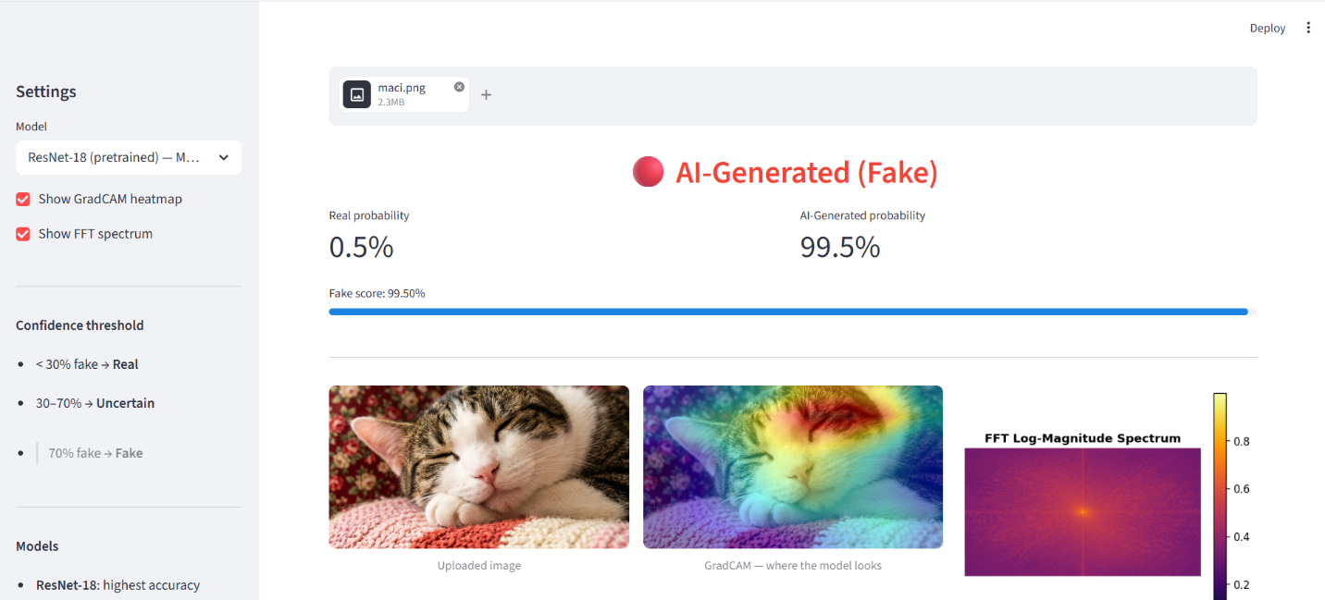
DALLE-E
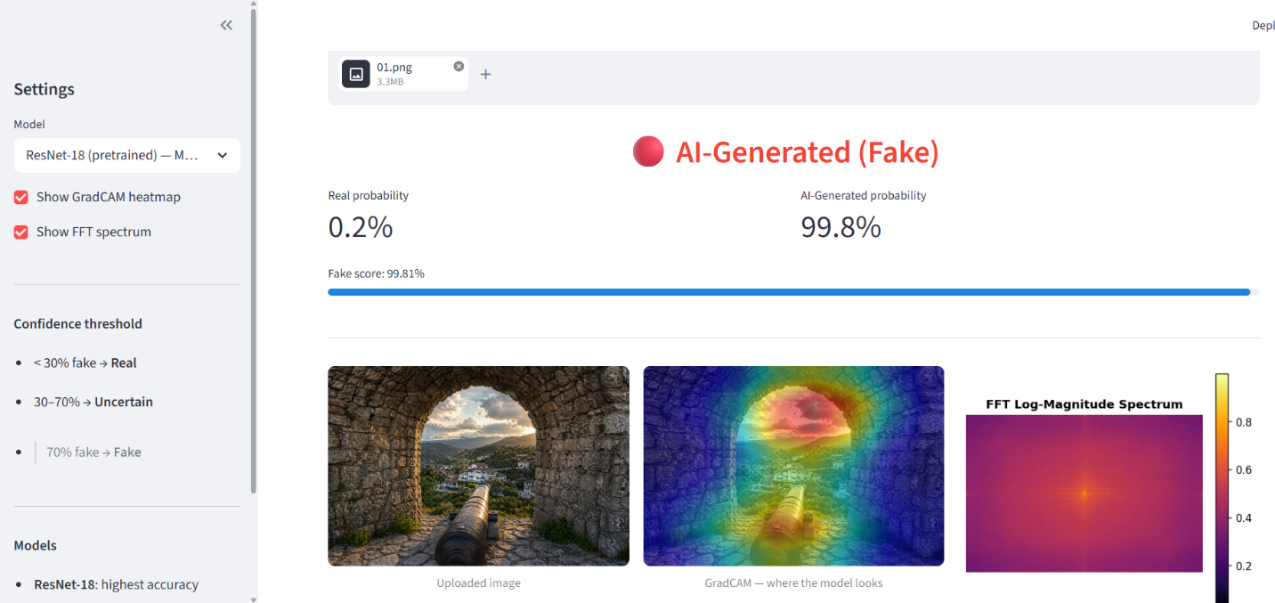
Stable Diffusion
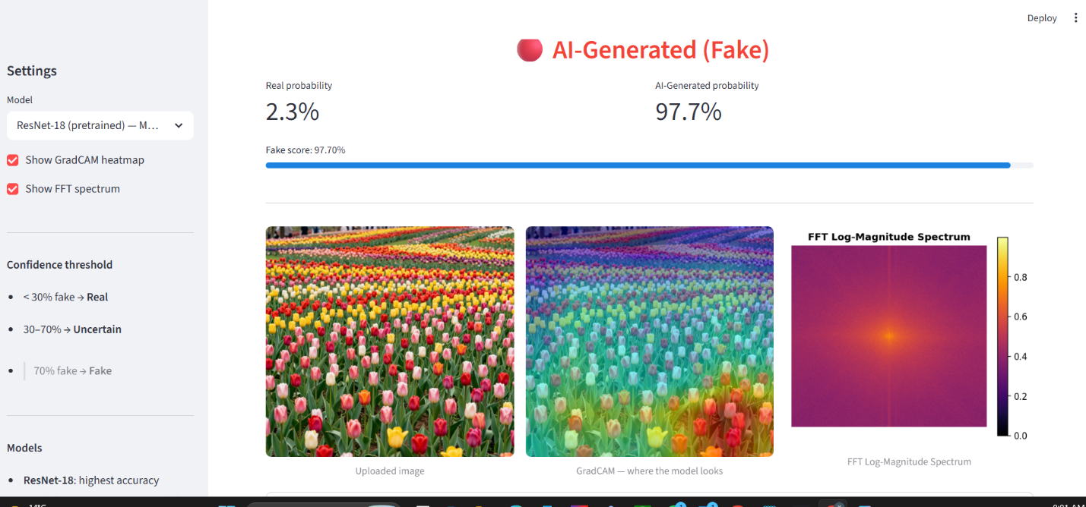

References

[1] Goodfellow, I., Pouget-Abadie, J., Mirza, M., Xu, B., Warde-Farley, D., Ozair, S., Courville, A., & Bengio, Y. (2014). *Generative Adversarial Nets*. Advances in Neural Information Processing Systems (NeurIPS), 27.

[2] Ho, J., Jain, A., &Abbeel, P. (2020). *Denoising Diffusion Probabilistic Models*. Advances in Neural Information Processing Systems (NeurIPS), 33.

[3] Rombach, R., Blattmann, A., Lorenz, D., Esser, P., &Ommer, B. (2022). *High-Resolution Image Synthesis with Latent Diffusion Models*. Proceedings of the IEEE/CVF Conference on Computer Vision and Pattern Recognition (CVPR).

[4] LeCun, Y., Bengio, Y., & Hinton, G. (2015). *Deep Learning*. Nature, 521, 436–444.

[5] He, K., Zhang, X., Ren, S., & Sun, J. (2016). *Deep Residual Learning for Image Recognition*. Proceedings of the IEEE Conference on Computer Vision and Pattern Recognition (CVPR), 770–778.

[6] Cooley, J. W., & Tukey, J. W. (1965). *An Algorithm for the Machine Calculation of Complex Fourier Series*. Mathematics of Computation, 19(90), 297–301.

[7] Cortes, C., &Vapnik, V. (1995). *Support-Vector Networks*. Machine Learning, 20(3), 273–297.

[8] Mirsky, Y., & Lee, W. (2021). *The Creation and Detection of Deepfakes: A Survey*. ACM Computing Surveys, 54(1), 1–41.

[9] Frank, J., Eisenhofer, T., Schönherr, L., Fischer, A., Kolossa, D., & Holz, T. (2020). *Leveraging Frequency Analysis for Deep Fake Image Recognition*. Proceedings of the International Conference on Machine Learning (ICML).

[10] Namani, Y., Reghioua, I., Bendiab, G., Labiod, M. A., &Shiaeles, S. (2024). *DeepGuard: Identification and Attribution of AI-Generated Synthetic Images*. Sensors, 24(15), 4818. https://doi.org/10.3390/s24154818

[11] Saskoro, R. A. F., Yudistira, N., & Fatyanosa, T. N. (2024). *Detection of AI-Generated Images from Various Generators Using Gated Expert Convolutional Neural Network*. IEEE Access.

[12] Wang, S. Y., Wang, O., Zhang, R., Owens, A., & Efros, A. A. (2020). *CNN-Generated Images Are Surprisingly Easy to Spot... For Now*. Proceedings of the IEEE/CVF Conference on Computer Vision and Pattern Recognition (CVPR).

[13] Rossler, A., Cozzolino, D., Verdoliva, L., Riess, C., Thies, J., &Nießner, M. (2019). *FaceForensics++: Learning to Detect Manipulated Facial Images*. Proceedings of the IEEE/CVF International Conference on Computer Vision (ICCV).

[14] Cozzolino, D., Poggi, G., & Verdoliva, L. (2020). *DeepFake Detection by Analyzing Convolutional Traces*. Proceedings of the IEEE/CVF Conference on Computer Vision and Pattern Recognition Workshops (CVPRW).

[15] Paszke, A., Gross, S., Massa, F., Lerer, A., Bradbury, J., Chanan, G., ... & Chintala, S. (2019). *PyTorch: An Imperative Style, High-Performance Deep Learning Library*. Advances in Neural Information Processing Systems (NeurIPS), 32.

